Assignment 1

1.Which one is the IP address of your machine?
Ans: 192.168.29.125
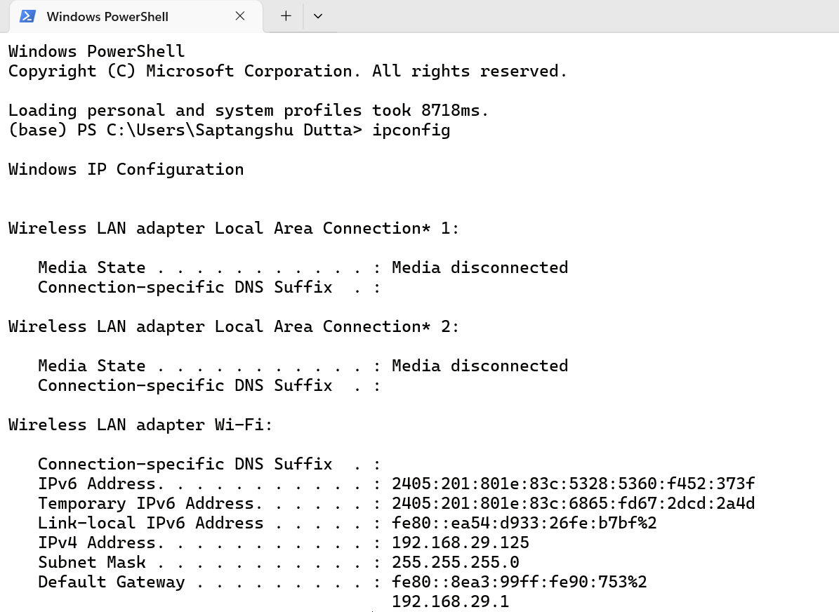

2. What is the difference between two commands ifconfig and ifconfig -a?
Ans: ifconfig shows only active network interfaces, while ifconfig -a shows all network interfaces, regardless of whether they are active or inactive.

3.Which one is the loopback IP address of your machine?
Ans: 127.0.0.1
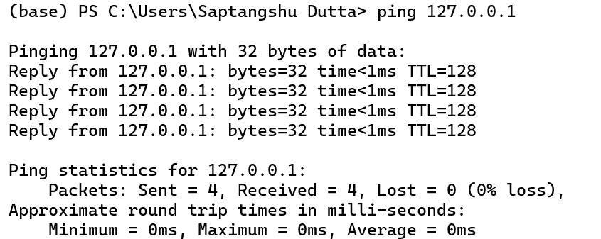
4. What is the name of your ethernet interface?
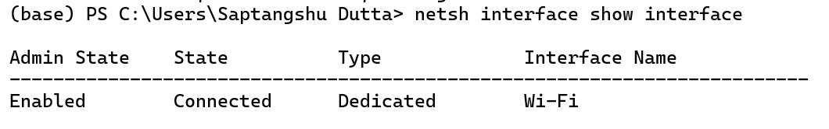

5. What is the network mask?
Ans: 255.255.255.0

6.What is the difference between ping command and tracert or traceroute command?
Ans: The fundamental difference is that ping checks if a destination is reachable and how fast it responds, while tracert or traceroute maps out the exact route a network packet takes to reach that destination.

7. Suppose the ping statistics shows
--- google.com ping statistics ---
3 packets transmitted, 3 received, 0% packet loss, time 2003ms
rtt min/avg/max/mdev = 32.516/32.600/32.713/0.169 ms
What do you mean by this?
Ans: Packet Summary - My computer sent 3 small test messages (packets) to Google's server, and Google successfully answered all 3 of them. Every single message made it there and back safely. This means my connection is stable and not dropping data (0% packet loss).
RTT (Round Trip Time) - The fastest single round trip took roughly 32.5 milliseconds. The average speed of all 3 packets was 32.6 milliseconds. The slowest single round trip took roughly 32.7 milliseconds.
The Stability Indicator - mdev = 0.169 ms: This stands for Mean Deviation. It measures jitter, which is how much our ping times vary from the average.

8. Issue the following command to find the address
host google.com
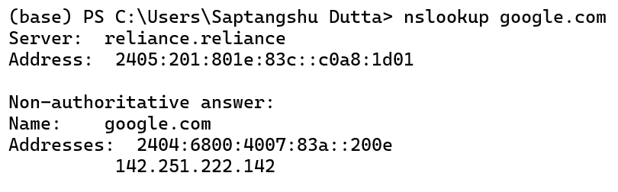

9. What is the output of netstat -a?
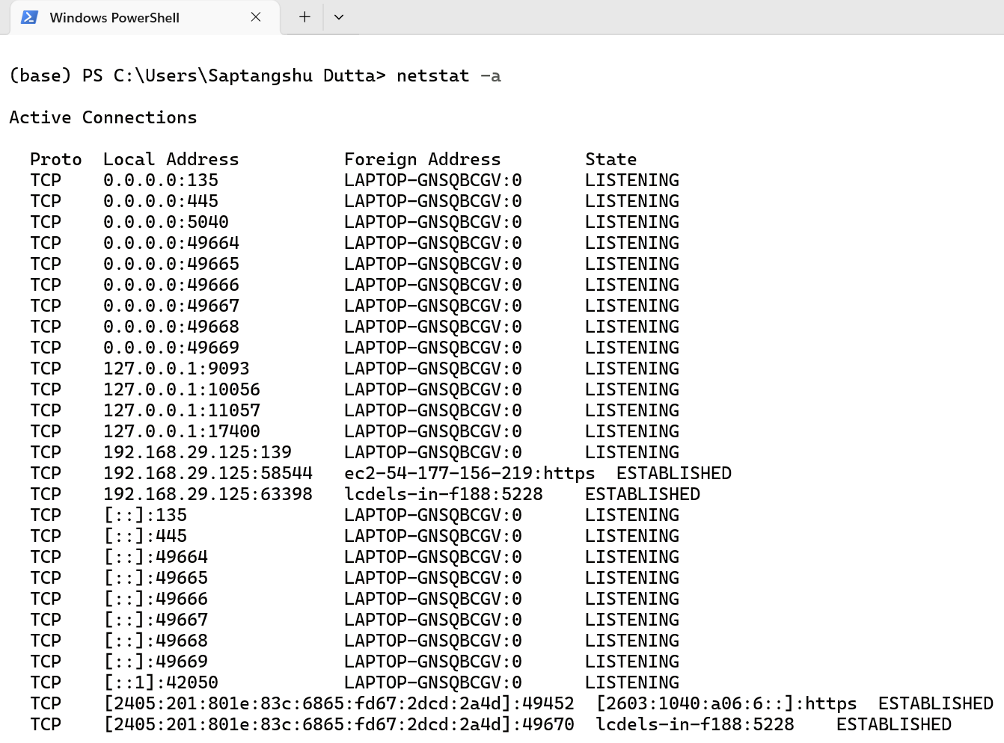

11. What is the output of ps -aux?
